Project 3

Check Box and Option Button Controls
Make a new directory called Project3 to be used to save a new form and project called styleandsize.frm and styleandsize.vbp respectively.
On the form place, position and size the following controls:
One label (LabelText)
Two frames (frameStyle and frameSize)
Three check boxes within frameStyle (checkBold, checkItalic and checkUnderline)
Four option buttons within frameSize (option12point, option135point, option18point and option24point)
One command button (CommandClose)
The program listing that follows is the text version of both the form design and code. The listing is the text used to store the data within a form. This listing has three parts.
- The Form properties as text which starts with VERSION 5.00 Begin VB.Form Form1
- The form attributes which begins with Attribute VB_Name = "Form1"
- The form code section which begins with Private Sub checkBold_Click()
Set the properties as shown on the attached printout. Not all of the properties can be accessed, so only set those that you can access. Start with the object names and captions. Once completed the form should look like the diagram below.
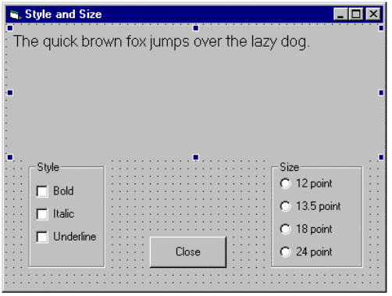
Code the sub procedures for each control as shown on the attached printout. Also change the properties for the objects to match those of the form properties list. To start use only the names and captions. Later change the other properties such sizes (left, top, width and height). Note there are some properties that are not editable such as client height and width these are determined by the size of the screen.
Run the program and check that it functions correctly. Use Debug if necessary.

Extra work
You may wish to experiment with the program to add other functionality. This may be to add strike out to the style check boxes.

Program listing: Properties, Attributes and Code
VERSION 5.00
Begin VB.Form Form1
Caption = "Style and Size"
ClientHeight = 4185
ClientLeft = 60
ClientTop = 345
ClientWidth = 5970
LinkTopic = "Form1"
ScaleHeight = 4185
ScaleWidth = 5970
StartUpPosition = 3 'Windows Default
Begin VB.CommandButton CommandClose
Caption = "Close"
Height = 495
Left = 2280
TabIndex = 10
Top = 3360
Width = 1215
End
Begin VB.Frame FrameSize
Caption = "Size"
Height = 1695
Left = 4200
TabIndex = 5
Top = 2160
Width = 1455
Begin VB.OptionButton Option24Point
Caption = "24 point"
Height = 250
Left = 120
TabIndex = 9
Top = 1320
Width = 1215
End
Begin VB.OptionButton option18point
Caption = "18 point"
Height = 250
Left = 120
TabIndex = 8
Top = 960
Width = 1215
End
Begin VB.OptionButton option135point
Caption = "13.5 point"
Height = 250
Left = 120
TabIndex = 7
Top = 600
Width = 1215
End
Begin VB.OptionButton option12point
Caption = "12 point"
Height = 250
Left = 120
TabIndex = 6
Top = 240
Width = 1215
End
End
Begin VB.Frame framestyle
Caption = "Style"
Height = 1695
Left = 360
TabIndex = 1
Top = 2160
Width = 1215
Begin VB.CheckBox checkUnderline
Caption = "Underline"
Height = 495
Left = 120
TabIndex = 4
Top = 960
Width = 1000
End
Begin VB.CheckBox checkItalic
Caption = "Italic"
Height = 495
Left = 120
TabIndex = 3
Top = 600
Width = 1000
End
Begin VB.CheckBox checkBold
Caption = "Bold"
Height = 495
Left = 120
TabIndex = 2
Top = 240
Width = 1000
End
End
Begin VB.Label LabelText
Caption = "The quick brown fox jumps over the lazy dog."
BeginProperty Font
Name = "MS Sans Serif"
Size = 12
Charset = 0
Weight = 400
Underline = 0 'False
Italic = 0 'False
Strikethrough = 0 'False
EndProperty
Height = 1935
Left = 120
TabIndex = 0
Top = 120
Width = 5775
End
End
Attribute VB_Name = "Form1"
Attribute VB_GlobalNameSpace = False
Attribute VB_Creatable = False
Attribute VB_PredeclaredId = True
Attribute VB_Exposed = False
Private Sub checkBold_Click()
If checkBold.Value = 1 Then
LabelText.FontBold = True
Else
LabelText.FontBold = False
End If
End Sub
Private Sub checkItalic_Click()
If checkItalic.Value = 1 Then
LabelText.FontItalic = True
Else
LabelText.FontItalic = False
End If
End Sub
Private Sub checkUnderline_Click()
If checkUnderline.Value = 1 Then
LabelText.FontUnderline = True
Else
LabelText.FontUnderline = False
End If
End Sub
Private Sub CommandClose_Click()
End
End Sub
Private Sub option12point_Click()
LabelText.FontSize = 12
End Sub
Private Sub option135point_Click()
LabelText.FontSize = 13.5
End Sub
Private Sub option18point_Click()
LabelText.FontSize = 18
End Sub
Private Sub Option24Point_Click()
LabelText.FontSize = 24
End Sub

